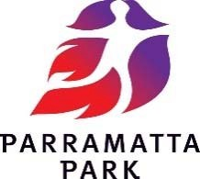

Terms & Conditions of Hire – General

The terms and conditions of hire have been developed to ensure the safe and equitable use of park facilities and to minimise impacts of activities on other park visitors and/or nearby residents and stakeholders.

COVID‐19 update:
Due to COVID-19, there are strict rules in place to limit the number of people gathering. As the Hirer, it is your responsibility to monitor and to comply with all NSW Government health requirements. For the latest information regarding the COVID-19 rules in New South Wales visit www.nsw.gov.au/covid-19.

Fees, Charges & Payment
Fees & charges consist of a site hire fee, and in some cases fees for entertainment and other inclusions and a bond.
Unless requested by the Trust, private bookings do not attract a bond. In the case of a private booking the individual making the booking is the “responsible person” and is liable for any costs incurred by the Park Trust arising from the booking such as damage to facilities or removal of rubbish and/or litter after use.
Transmission of an online booking form or submission of a manual application does not guarantee a reservation.
Bookings are not confirmed until payment in full has been received by the Trust. Partial payment is not accepted.

Cancellations & Refunds
If you choose to cancel your shelter hire after it has been confirmed a cancellation fee will be deducted from the fees paid before they are refunded.
All cancellations must be received in writing or via email.
The cancellation fee is calculated based on the amount of notice given. Where 7 days or more notice is provided a
$50.00 administration and processing fee will be deducted from any fees paid. If less than 7 days’ notice is provided all fees will be forfeited.
If you choose to cancel on the day of your booking due to adverse weather no refunds apply, and all fees paid will be forfeited.
If a refund is requested for any other reason, an investigation is conducted and once approved, a percentage or a full refund is processed.
The Trust may cancel any booking by telephone, via email or in writing sent to the responsible person. If the Trust does cancel a booking a full refund of the hire fee paid will apply and is processed within 10 working days.

Booking Errors
If you make an error while booking online and wish to cancel your booking, to be eligible for a full refund you must advise us via email (or in writing) within 24 hours of you finalising your booking. Any requests received after this time will be treated as a standard cancellation.

Alterations
If you choose to alter your shelter hire for any reason after it has been confirmed an additional fee may apply. All requests must be received in writing or via email with at least 7 days’ notice prior to your event. You are only able to alter the booking information; no alteration or change can be made to the area hired once your booking has been confirmed.

Postponement
If you choose to postpone your shelter hire after it has been confirmed an additional fee may apply. All requests must be received in writing or via email with at least 7 days’ notice prior to your event. Any requests received after this time will be treated as a standard cancellation.

Reservations
A sign at the hired shelter will notify other park visitors that the area is reserved for your booking. If you are running late on the day of your booking contact the Duty Ranger on 0419 122 763 to ensure your booking is held. If you do not contact

the Duty Ranger your shelter reservation will only be held for 30 minutes past the recorded commencement time and after this period, the area will be available for use by other park visitors. Booking fees will be forfeited and are not transferable to another date.

Advertisement of Event
The external advertisement and promotion of any event or function must be approved by the Trust prior to publication or use thereof in any media. The Trust may withhold approval at its absolute discretion.

Public Liability Insurance
Individuals who hire an area of the Park for private functions are generally not required to provide Public Liability Insurance, although this may be requested depending on individual activities and / or hiring applications. Any organisation that reserves an area of the Park must provide the Trust with a copy of their Certificate of Currency for Public Liability Insurance of not less than AU$10 Million prior to the hire being confirmed.

Catering / Entertainment / Other Inclusions
The following items may only be used only with the prior written approval of the Trust:
- Any marquees, stalls or shade structures larger than 3m x 3m;
- Animals and/or mobile zoos provided for entertainment or display;
- Amusements and rides such as jumping castles;
- Onsite Caterers/coffee carts/spit roasts;
- Power and generators;
- Amplified music, public announcement systems, musical performances and the playing of musical instruments; and
- Signage, including directional signs, banners and displays.

Shade Structures
Use of one (1) free standing, open**, domestic-size shade structure (no larger than 3m x 3m) or umbrella is permitted on the condition that it is properly weighted down. Pegging of any kind is not permitted. If the conditions are windy or the shade structure is at risk of blowing away, for your own safety and the safety of other visitors Trust staff may direct you to remove the shade structure. All park visitors are required to follow Trust staff and officer’s instructions to dismantle any shade structure / marquee / tent that is not permissible or is deemed unsafe.

Access
The picnic areas are often very busy with visitors including children so for safety reasons unauthorised vehicles are not permitted beyond the road system within the Park track and recreational areas, including access to shelters.

Vehicle Parking
To ensure visitor safety and access in popular picnicking areas, the Parklands operates Restricted Parking Area schemes in a number picnicking reserves. Parking is permitted only in marked bays. Bays are marked by signs and symbols and time restrictions apply in some areas. It is
illegal to park outside of marked bays or overtime and fines apply for noncompliance. Visitors may contact Revenue NSW for fine enquiries 1300 130 112

All vehicles must use designated vehicle access routes to, from and through the Parklands and must observe signs and directions and Regulations at all times. It is the driver’s responsibility to read and abide by traffic signs within Parramatta Park.
Restrictions apply to buses and a Bus Access Permit must be obtained from the Trust website before buses enter the Park. Bus drivers must adhere to the Park's traffic management system at all times.

BBQs
The park BBQs do not form part of any booking. They are intended for small family groups only and will not service large groups. They are provided for shared use and are free of charge. Please leave them as you would like to find them.
During ‘TOTAL FIRE BAN’ periods only the Park’s BBQs are permitted for use. Fires of any kind are not permitted. On the day of your booking check the NSW Rural Fire Service website (hhtp://www.rfs.nsw.gov.au/) for Total Fire Ban status. Heavy fines apply for noncompliance with the Rural Fires Act 1997.

Bonds
Bonds are required for bookings that have approved structures, entertainment, amusements or other inclusions onsite. All school bookings (excluding shelter hire), seasonal bookings and general bookings with over 200 people attending also require bond.

Bonds are refunded within 4 weeks after the booking date. Bonds are only refunded in full if all booking conditions have been met & the area is left free from litter &/or damage.

Commercial Activities
Any money-making activities including the sale of goods, food and / or beverages at shelters and/ or mobile vans, fundraising activities and / or personal training / boot camps are not permitted without prior written approval from the Trust.

Noise
Noise from radios or the like, public address systems, amplifiers and musical instruments must be kept to a level that does not cause nuisance to other visitors. The Duty Ranger or other Trust officer has sole discretion in determining whether interference or nuisance is taking place and may issue directions to the responsible person as to any remedial action to be taken.
It is an offence to fail to comply with the reasonable direction of an authorised officer.

Decorations
Balloons, streamers, signs and like decorations may only be attached to picnic shelters with string. The use of thumbtacks, sticky tape, nails or the like damages facilities and is not permitted. All decorations must be removed at the end of the booking. Failure to remove decorations and the

like, may result in charges for clean-up and is littering, and fines apply for non-compliance.
Confetti, rice, rose petals, party poppers, paint dyes or powders and the like may not be used in the Parklands. Use of these is littering. Helium balloons must not be brought into or used in the Parklands at any time.
Signs, decorations, tarpaulins or similar items must not be attached to trees or plants in the Parklands. Fines apply for noncompliance.

Sporting Activities
Ball games are permitted within the Park. Participants must respect the safety and enjoyment of other visitors and not interfere with their use of the Park.
Any courses and playing areas for sporting activities must be marked with traffic cones or similar free-standing equipment and the course or playing area and method of marking is subject to prior approval by the Trust.
Pegging of any kind is not permitted over most of the Park. Cricket wickets and volleyball nets must be free standing. Pegging in designated areas is only permitted with prior approval of the Trust.

Alcohol Consumption
Consumption of alcohol is permitted within the Park when consumed responsibly and legally.
Where guests are served alcohol for consumption as part of the booking with or without a fee, entry ticket or other charge, a liquor license may be required. You are required to refer to the Office of Liquor and Gaming and confirm what licensing requirements apply for your activity and ensure you comply with all relevant requirements.

Waste Management
All waste and litter must be placed either in the bins provided in the Park or removed from the Park by the responsible person. In the event that the Trust incurs additional expense resulting from the removal of any rubbish left at the booked area or surrounds, including any rubbish left lying adjacent to the bin stations, the cost will be charged to the responsible person by withholding all or part of the
bond or by invoice for private functions where no bond is charged.
Hot coals, ice and oil must not be put on the ground in the Park as it damages the grass.

After Hours Access
Where any booking requires access to park facilities outside the hours of 9am to 4pm Monday to Sunday, a call out fee
may be charged to arrange for securing facilities such as power or gates. Such access is subject to prior approval by the Trust.
Where deemed necessary for the proper management of the booking, the Trust may require RMS qualified traffic controllers to assist at events and large private functions. In this instance the Trust will engage suitably qualified personnel and this cost shall be charged to the responsible person or event organiser. The Trust shall have the right to determine if this additional service is required.

Additional Requirements
In addition to the Terms & Conditions of Hire all park visitors are required to comply with the Parramatta Park Trust Act 2001 and the Parramatta Park Trust Regulations 2019.

Failure to Comply
All park users including responsible persons are required to ensure that they adhere to the terms and conditions of hire and the Parramatta Park Regulations 2019.
Failure to comply with the any of the terms and conditions of hire or any reasonable request by an Authorised Trust Officer may result in the cancellation of your booking.
In the case that your booking is cancelled due to non- compliance all fees will be forfeited.
In addition to the cancellation of your function, fines can apply for breaches of the Parramatta Park Regulations 2019.

Use of Parramatta Park facilities is subject to the Parramatta Park Act 2001 and Parramatta Park Regulation 2019. Failure to comply with the Terms and Conditions herein or any reasonable request of an Authorised Trust Officer may result in the cancellation of a shelter hire. Trust officers may cancel, refuse or alter any shelter hire at their discretion and shall notify the nominated contact or responsible person accordingly.

bookings@ppt.nsw.gov.au (02) 9895 7500

**

Allowable 3m x 3m shade structures
(Written approval from the Trust is required for enclosed 3m x 3m structures or for any other structure not pictured below):
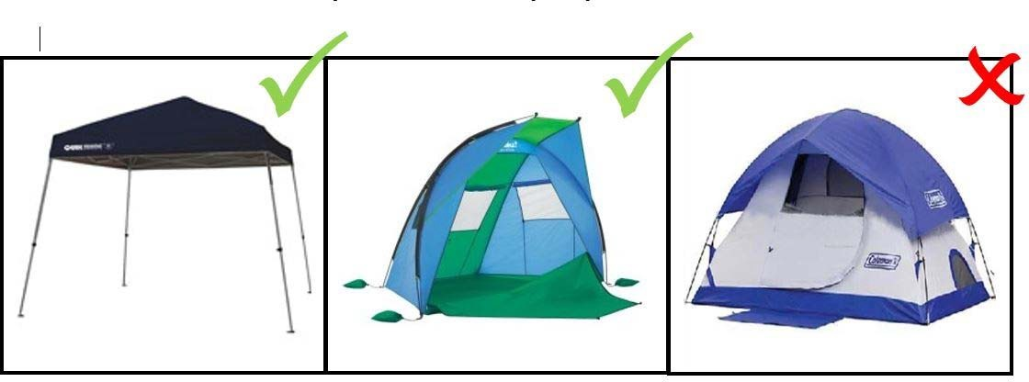

Use of Parramatta Park facilities is subject to the Western Sydney Parklands Act 2006 and Western Sydney Parklands Regulation 2019. Failure to comply with the Terms and Conditions herein or any reasonable request of an Authorised Trust Officer may result in the cancellation of a shelter hire. Trust officers may cancel, refuse or alter any shelter hire at their discretion and shall notify the nominated contact or responsible person accordingly.

bookings@ppt.nsw.gov.au (02) 9895 7500

